Standard Operating Procedure (SOP)

Authors & Contributors
G. Mwanje, R. Kanaabi, C. Serebe, N. Kinalwa, J. Kisitu, Y. A. Kolombia and G. V. Nakato*

*Correspondence: V.Nakato@cgiar.org

1. Introduction
Banana weevils are a very important pest that contributes to the decline in production and disappearance of bananas in some regions of Uganda (Gold et al., 1993). This pest can cause yield loss ranging from 5% in the first cycle to 40% in the fourth ratoon cycle (Rukazambuga et al., 1998). However, a loss of up to 100% can also be obtained starting from the fourth ratoon cycle (Sengooba, 1986; Gold et al., 2004). The measures used to control banana weevil damage vary widely depending upon the type of banana production system practiced (Padmanaban and Sathiamoorthy, 2001). One of the control measures is the use of chemicals (Masanza, 2003), mainly in commercial production (Gold and Messiaen, 2000). Cultural control strategies are also being applied and they are of greater significance to resource-limited farmers cultivating bananas for subsistence production (Padmanaban and Sathiamoorthy, 2001). Biological control measures like the use of exotic natural enemies, endemic natural enemies, secondary host associations, and microbial control, for example, entomopathogens, endophytes, and entomo-phagous nematodes (Gold et al., 2001). Germplasm improvement to develop resistant cultivars is the most sustainable solution to control of banana weevils (Tinzaara et al., 2009). However, the genotypes used in the banana improvement for weevil resistance need to be evaluated for resistance against banana weevils. Banana being a long-cycle crop, field screening for weevil resistance takes a long time (Kiggundu et al., 2000). This document describes standard operating procedures (SOPs) for screening for banana resistance to weevils in a reliable, resource-saving manner.

2. Purpose
The purpose of this SOP is to describe the procedure to be followed when screening for banana resistance in potted experiments in a reliable, resource-saving manner.

3. Scope
This SOP covers the following: the materials used; selection of the genetic material to test; multiplication, weaning, and transplanting of tissue culture plantlets; the experimental design; collection; rearing of banana weevils; sex determination of banana weevils; inoculation of the experiment; data collection and analysis.

4. Definition of terms
Inoculation: the process of introducing banana weevils into the experiment so that they can infest the plants.
Rostrum: an extension (snout-like projection) from the head of a banana weevil.

5. Roles and Responsibilities
Research Technicians are responsible for Tissue Culture laboratory plantlet generation, inoculum preparation, inoculation, data collection, data curation, and analysis.
Pathologists/Research Assistants is/are responsible for experiment planning and supervision.
Pathologist/breeders are responsible for data analysis and publications.
Field Assistants are responsible for weevil collection.

6. Procedure/Protocols
Step 1: Experimental Planning (Pathologist/ Research Assistant)
Materials and methods
Plant materials
1) Tissue culture generated plant material including:
- Test genotypes
- Resistant check:
- Calcutta 4
- Susceptible check:
  - Mbwazirume
  - TMP-28 OBINO LEWAI
- Land races controls
- TMP-28 OBINO LEWAI
- Mbwazirume
- Mchare

Other materials
1. Sterile Forest soil or Loam soil
2. Sterile sand or saw dust
3. Weevil proof nets
4. 13-liter plastic pots
5. Watering cans
6. Weevils
Step 2: Multiplication, weaning, and transplanting of tissue culture plantlets (research technician of the tissue culture laboratory).
- The genotypes to be screened are generated from tissue culture (TC).
- These are left in the nursery in a humid chamber for 4 weeks and later hardened under shade in the nursery for four more weeks. (Refer to IITA-BP-SOP06-06 Weaning SOP)
- After hardening off, genotypes are planted in 13-litre volume plastic buckets that are filled with a mixture of sterilized topsoil, farm manure, and saw dust in the ratio of 3:1:1 respectively.
- Buckets are then sealed off with weevil poof nets to prevent weevils from the nearby fields from entering them. The buckets are then organized according to the design in open space under shade.
- Genotypes are allowed to establish themselves for three months in order to attain a suitable corm size before the introduction of weevils.
- Watering is done regularly to enable the establishment of the suckers.
Step 3: Design of an experiment (Research Assistant)
A suitable experimental design should be selected considering the prevailing factors in terms of space, time, materials, and data quality.
In this case, we are going to focus mainly on the partially replicated design. A partially replicated experimental design (P-Rep) with three blocks will be adopted, with each test genotype occurring in duplicate and the checks in triplicate for the entire experimental set up. Each plot will have four plants per genotype. The P-rep design is useful when plant materials and space are limiting factors. The P-rep design allows trial evaluations in batches.
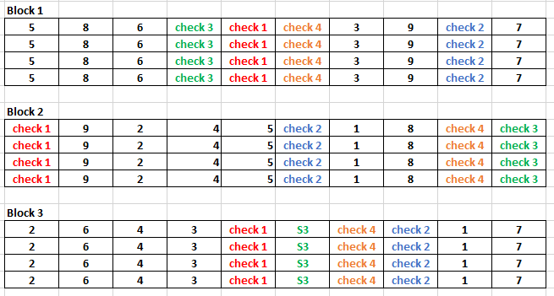
Figure 1:Illustration of P-Rep design for 3 blocks,9 test genotypes and 4 checks

Step 4: Collection and rearing of banana weevils (Field assistant)
- Banana weevils are collected from the old, infested banana plantations using pseudo stem traps.
- The pseudo stems are cut into pieces of about 30 cm long and then split longitudinally into halves.
- The split pseudo stems are then placed near the banana mats and left for one day, as described by Viljoen et al. (2017).
- The trapped weevils are collected into 30-litre ventilated buckets and kept in a cool, conducive place.
- The banana weevils are cultured and maintained by feeding them with fresh pared corms of a highly susceptible variety (Mbwazirume), and these corms are changed weekly.
Step 4.1: Determination of the sex of the banana weevils (Research technician and research assistant)
N.B Because infestation of the genotypes with weevils is done by adding 3 female and 3 male weevils (when using tissue culture plantlets) to each pot/bucket, it is important to determine their sex. When using suckers, the ratio of male weevils to female weevils should be 5:5.
- Once the weevil colony is established, the sex of each weevil is determined by viewing the weevil through a stereo microscope.
- The male has a fully punctuated rostrum and the female has less than half a punctuated rostrum (Viljoen et al., 2017) – Appendix 1
- The sex of the banana weevil may also be determined based on the shape of the last abdominal segment.
- When the last abdomen segment is viewed laterally, it curves more sharply downwards than that of the female, which is flatter (Roth and Willis, 1963).
Step 5: Experiment Inoculation (Research Technician and Research Assistant)
- Three months after the establishment of the experiment, three female and three male weevils are placed at the base of each plant in the
- Then each bucket is sealed off again using a weevil-proof net to prevent the introduced banana weevils from escaping.
- After 60 days from the time of banana weevil introduction into the buckets, the plants are uprooted and the damage caused by the banana weevils is estimated based on the cross-section method as described by Gold et al. (1994).
Step 6: Data collection (Research technician and Research assistant)
- Banana weevil damage is assessed 60 days after inoculation.
- The following traits are evaluated:
- Peripheral damage (%)
- Outer upper cross-section damage (%)
- Inner upper cross-section damage (%)
- Outer lower cross-section damage (%)
- Inner lower cross-section damage (%)
- Total cross-section damage (%).

- The cross-section damages are assessed by cutting a transverse cross-section both at the collar (upper cross-section) and 2 cm (which can be adjusted depending on the size of the corm) below the collar (lower cross-section).
- Weevil damage is scored as percentage damage on the upper cross-section and lower cross-section for both the inner corm (central cylinder) and the outer corm (cortex)-Appendix 2
- For each cross-section, weevil damage is assessed independently for the central cylinder and the cortex by estimating the percentage of corm tissue damaged by the weevil in each area.
- The mean of the four scores (inner upper cross-section, inner, outer upper cross-section, inner lower cross-section, and outer lower cross-section) is calculated to generate a total cross-section damage estimate.
Step 7: Data Analysis (Pathologist or Breeder)
Multiple experiments
- To determine the variation among genotypes, multiple experiments/meta-analysis (REML) analysis is carried out using GenStat or any other statistical package.
- Both Dunnett’s test, Fisher protected least significant different test, or any other mean separating test using GenStat or any other powerful statistical package are used to separate the resistant genotypes from susceptible genotypes with comparison to the resistant and susceptible checks.
Single experiment
To determine the variation among genotypes in one batch, REML analysis is carried out using the GenStat statistical package or any other statistical package.

7. References
Abera, A.M.K., 1997. Oviposition preferences and timing of attack by the banana weevil (Cosmopolites sordidus, Germar) in East African highland banana (Musa spp.). Unpubl. Unpublished M. Sc. thesis. Makerere University, Kampala, Uganda.
Gold ,C.S and Messiaen .S., 2000. The banana weevil, Cosmopolites sordidus. Musa Pest Fact Sheet No. 4, INIBAP, Montpellier.
Gold CS, Kagezi GH, Night G, Ragama PE. 2004. The effects of banana weevil, Cosmopolites sordidus, damage on highland banana growth, yield and stand duration in Uganda. Annals of Applied Biology, 145(3), pp.263-269.
Gold CS, Ogenga-Latigo MW, Tushemereirwe W, Kashaija I, Nankinga C. 1993. Farmer perceptions of banana pest constraints in Uganda: Results from a rapid rural appraisal. Ibadan, Nigeria: Biological and Integrated Control of Highland Banana and Plantain.
Gold CS, Pena JE, Karamura EB. 2001. Biology and integrated pest management for the banana weevil Cosmopolites sordidus (Germar) (Coleoptera: Curculionidae). Integrated Pest Management Reviews, 6(2), pp.79-155.
Gold, C.S., Speijer, P.R., Karamura, E.B., Tushemereirwe, W.K. and Kashaija, I.N., 1994. Survey methodologies for banana weevil and nematode damage assessment in Uganda. African crop science Journal. 2, 309–321.
Kiggundu A. 2000. Host plant reactions and resistance mechanisms to banana weevil, Cosmopolites sordidus (Germar) in Ugandan Musa germplasm. MSc Thesis, Orange Free State University, South Africa.
Masanza M. 2003. Effect of crop sanitation on banana weevil Cosmopolites sordidus (Germar) populations and associated damage (Doctoral dissertation, Wageningen University and Research Centre, the Netherlands).
Padmanaban B, Sathiamoorthy S. 2001. The banana stem weevil Odoiporus longicollis . Inibap. Musa Pest Fact Sheet No.5.
Roth, L.M. and Willis, E.R., 1963. The humidity behavior of Cosmopolites sordidus (Coleoptera: Curculionidae). Annals of the Entomological Society of America, 56(1), pp.41-52.
Rukazambuga NDTM, Gold CS, Gowen SR. 1998. Yield loss in East African highland banana (Musa spp., AAA-EA group) caused by the banana weevil, Cosmopolites sordidus Germar. Crop Protection, 17(7), pp.581- 589.
Sengooba T. 1986. Survey of banana pest problem complex in Rakai and Masaka Districts in Uganda. Namulonge, Uganda: Namulonge Research Station.
Tinzaara W, Kiggundu A, Gold CS, Tushemereirwe WK, Karamura EB. 2009. Management options for highland banana pests and diseases in East and Central Africa. Outlooks on Pest Management, 20(5), p.204.
Viljoen, A., Mahuku, G., Massawe, C., Ssali, R.T., Kimunye, J.,Mostert., G., Ndayihanzamaso, P. and Coyne, D.L 2017. Banana Diseases and Pests : Field Guide for Diagnostics and Data collection. International Institute of Tropical Agriculture (IITA), Ibadan, Nigeria.

8. Annex: Forms/Templates to be used for monitoring and data collection
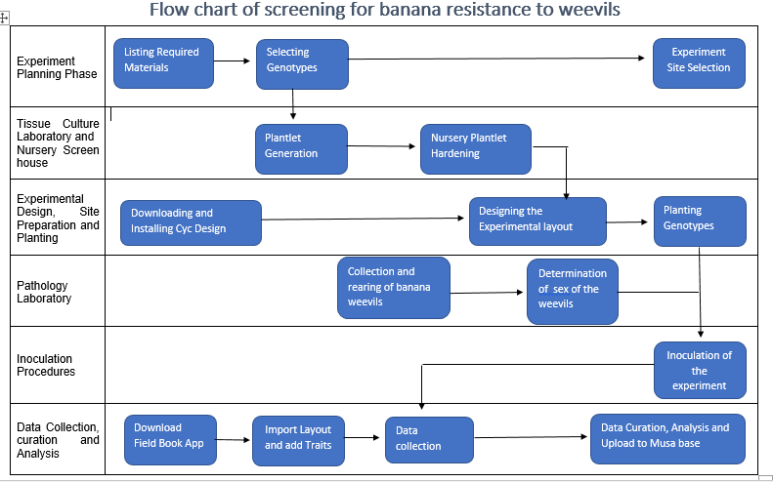

Appendix 1: Half punctuated rostrum of female banana weevil (A) and Fully punctuated rostrum of male banana weevil (B)
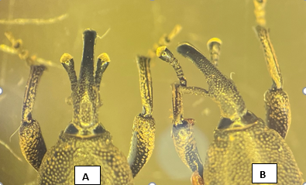

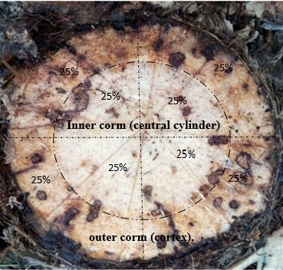
Appendix 2: The corm's inner and outer sections each scored out of 100%.

